**Mrs.Hoffmann’s Supply List**

Dear Parents,

I am excited to be teaching your child this year! Below is a list of items that students will use. If you are able to supply them ,that would be excellent. If not, don’t sweat it-- I will have a few “extras.” If you would like to donate any additional items to the classroom, there is a list for that too. These items will be used collectively and will not be returned at the end of the school year.



**Items Needed by Each Student**

* *scissors
* * a small pencil box or pouch
* *reusable water bottle
* *headphones
* one package of glue sticks (any amount)
* one package of **BLACK** whiteboard markers (any amount)

*These items will be returned at the end of the year.

**Additional Collective Items (YOU DON’T NEED TO BUY ALL THE ITEMS ON THIS LIST—CHOOSE A FEW, A COUPLE, OR NONE!)**

* Disinfectant wipes
* Gallon or quart size plastic bags
* Small toys for our treasure box (playdough, balls, bubbles, party favors, etc.)
* Tissues
* 1.3 mm mechanical pencils (these can be found online)
* 1.3 mm lead

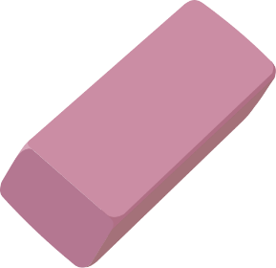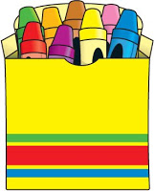

*I will be supplying students with folders, crayons and notebooks. Please don’t purchase these items for your child.